Let’s Go Further With Story Retell!
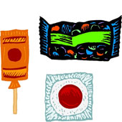 | Candy = Detail About the Characters  Have your child tell you about the character  Ex: How they felt, What they looked like, What they were like, What their motivation was, etc.
Soda = Detail About the Setting
Have your child tell you about the setting.
Your child should be able to tell you: Where the story took place, What time of day it was, If there was more than one location, etc.
Popcorn = More Detail About the Problem/Plot
Your child should be able to tell you major events that happened in the story WITH supporting details. (Beginning/Middle/End)
Ticket = Give More in the Take Away
What did you take away from the story? Their connections should be elaborate and include inferences from the text.
You may have noticed that the books your children are reading have a little more information/story to them. We need to work on getting them to provide as much information as possible without prompting. I thought we could use the same Story Retell process but tweak it a little. Here’s what I need you to do. Look at the new chart below and have your child give you the information requested. They should give you so much more detail than before. Please do this EVERY night when you read with your child. Remember 10 minutes of reading is required each night.

