Story Retell
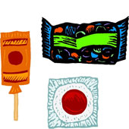 | Candy = Characters  Your child should tell you who the characters were in the story and any characteristics they can tell about the character.
Soda = Setting
Your child should be able to tell you all of the settings in the story. Where did the story take place? Where else?
Popcorn = Problem/Plot
Your child should be able to tell you what happened in the story/what the problem was in the story and if it was solved. (Lots of detail)
Ticket = Take Away
What did you take away from the story? Have you ever done anything like the character in the story? How did it make you feel?
We have been doing “Story Retell” in our room. This is where we read a story and then the children tell me about the story. We have been using a Movie Theater theme of retell so the students can remember the important pieces of the story easier. Please go over this at least 3 times a week. You don’t have to write anything down or turn anything in, but the more you do it the stronger readers your children will be. The children really have a lot of fun with this activity.

